Atrium Siphonic drainage calculations
A=1062m²
H=21.5m
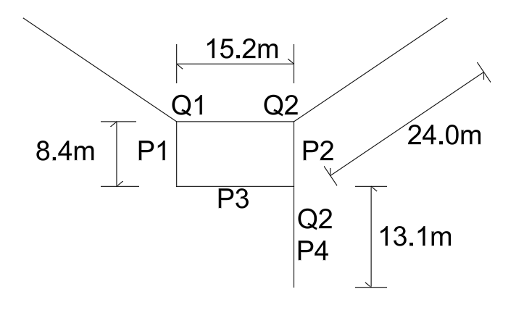
From Brief specified by the client, a design rainfall intensity of 0.02l/s/m²
1.3(climate factor) x 0.02 x 1.1 (safety factor) x 1062 (area) = 31.64l/s/m²
Q₁=Q₂ = 31.64/2 = 15.82l/s
Q₃=31.64l/s
1st Iteration using Cole-Brooke white formula
$$(\frac{u^{2}}{8gd_{i}}){\left\{\log\left[\frac{k_{p}}{3710d_{i}}+\frac{1.775v}{\sqrt{(gi_{f}d_{i}^{3})}}\right]\right\}}^{-2}$$
Q₁ = 0.01582m³/s
V₁ = 10.4m/s
------------------------------------------------------------------------------------------------------------------------
P₁: d₁ = 44mm X-SA = 0.001521m² L₁ = 8.4m Q₁ = 0.01582m³/s V₁ = 10.4m/s
P₂: “
P₃: d₃ = 44mm X-SA = 0.001521m² L₂ = 15.2m Q₁ = 0.01582m³/s V₃ = 10.4m/s
P₄: d₄ = 62mm X-SA = 0.003042m² L₄ = 13.1m Q₄ = 0.3164m³/s V₄ = 10.4m/s
BS 8490:2007
Downpipe min velocity = 2.2m/s
Horizontal pipe min velocity = 1.0m/s
Recommended min diameter to prevent blockages = 44mm
Roughness value: K_{p} = 0.15mm
If 8.4m head loss assumed for P₁

First Iteration: i_{f} = 1.4780
Inserting new i_{f} each iteration
(4 iterations): i_{f} = 1,722
Checking headloss due to friction
∆h_{f} -1.722 x 8.4 = 14.46 no good so increase in diameter
------------------------------------------------------------------------------------------------------------------------
P₁: d₁ = 60mm X-SA = 0.002827m² L₁ = 8.4m Q₁ = 0.01582m³/s V₁ = 5.596m/s
Use of Colebrook-White resistance equation as above
(4 iterations): i_{f} = 0.3868
∆h_{f} = 0.3868 x 8.4 = 3.249 passed
P₂: “
P₃: ∆h_{f} = 5.879
P₃∆h_{f} + P₁∆h_{f} = 9.128 > 8.4 no good
------------------------------------------------------------------------------------------------------------------------
P₁: d₁ = 0.07m X-SA = 0.003848m² L₁ = 8.4m Q₁ = 0.01582m³/s V₁ = 4.111m/s
I_{f} = 0.1843 (4 iterations) ∆h_{f} = 0.1843 x 8.4 = 1.5478
P₂: “
P₃: d₁ = 0.07m X-SA = 0.003848m² L₁ = 15.2m Q₁ = 0.01582m³/s V₁ = 4.111m/s
I_{f} = 0.1843 (4 iterations) ∆h_{f} = 0.1843 x 15.2 = 1.5478
P₄: d₁ = 0.099m X-SA = 0.007698m² L₁ = 13.1m Q₃ = 0.03264m³/s V₁ = 4.111m/s
I_{f} = 0.1220 (4 iterations) ∆h_{f} = 0.1220 x 13.1 = 1.5983
Total ∆h_{f} = 1.5983 + 2.8014 + 2 x 1.5478 = 7.4953m
Allowance for fittings: 1.4 x 7.4953 = 10.4933m
Velocity at point of discharge = 4.111
Velocity head H_{v} = $\frac{{4.111}^{2}}{2×9.81}$ = 0.8614
Check if H_{A} > H_{T} + H_{V} 21.5m > 0.8614+10.4933 = 11.3547 passed
Minimum head pressure (h_{m})
H_{m} = 7.4953 – 0.99 = 6.5053
6.5053m > -7.8m no risk of cavitation
------------------------------------------------------------------------------------------------------------------------
Priming time BS 8490:2007 <60s
T_{F} = $\frac{V_{P}}{Q_{in}}$ V_{P} = Volume of pipework Q_{in} = capacity of tailpipe before primed
Q_{in} = 4.5l/s (EN 12056-3: 2000)
P₁ Volume = 0.03232m³
P₂ Volume = 0.03232m³
P₃ Volume = 0.05849m³
P₄ Volume = 0.1008m³
T_{F} + $\frac{224}{4.5}$ = 50s
Gutter required to hold 50s x 31.64l/s/m² = 1582l
Total length of gutters = 63.2m
Required XS-A gutter = 25,031mm²

Wing Siphonic Drainage calcs
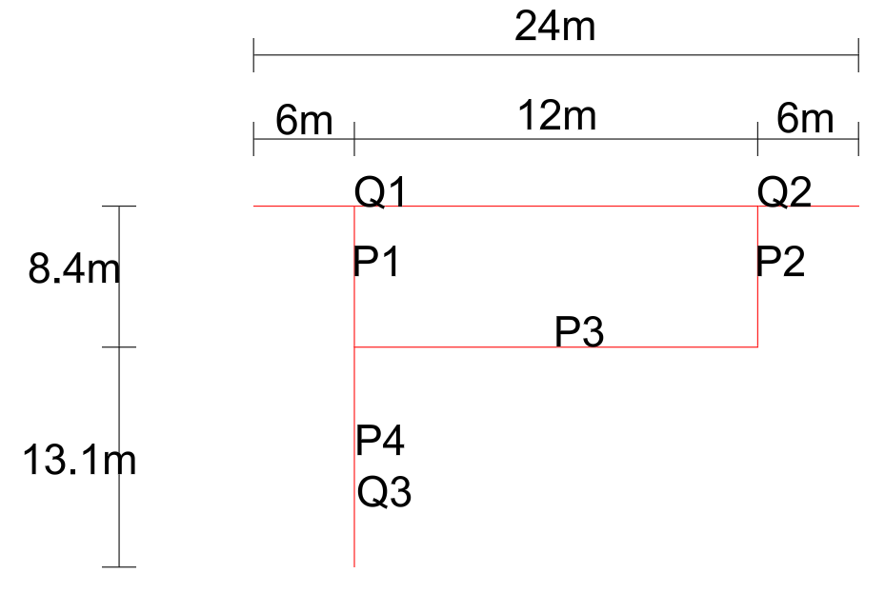
A=354m²
H_{A}=21.5m
Q₀=9.589 x 1.1 = 10.548l/s
Using Colebrooke-white equation as above for siphonic drainage design
P₁: d₁ = 0.044m X-SA = 0.001521m² L₁ = 8.4m Q₁ = 0.005274m³/s V₁ = 3.4675m/s
I_{f} = 0.2353m (4 iterations) ∆h_{f} = 0.2353 x 8.4 = 1.9765
P₂: “
P₃: d₁ = 0.044m X-SA = 0.001521m² L₁ = 12m Q₁ = 0.005274m³/s V₁ = 3.4675m/s
I_{f} = 0.2353 (4 iterations) ∆h_{f} = 0.2353 x 12 = 2.8220
P₄: d₁ = 0.062m X-SA = 0.003042m² L₁ = 13.1m Q₃ = 0.010548m³/s V₁ = 3.4675m/s
I_{f} = 0.1567 (4 iterations) ∆h_{f} = 0.1567 x 13.1 = 2.0518
H_{T} = 2.0518 + 2.8220 + 2 x 1.9765 = 8.8268m
To allow for fittings: 1.4 x 8.8268 = 12.3575m
Velocity (u) at point of discharge = 3.4675m/s
Velocity head H_{V} = $\frac{{3.475}^{2}}{2×9.81}=0.6128$
Check if H_{A} > H_{T} + H_{V}
21.6 > 0.6128 + 12.3575 = 12.9703m passed
Priming time: T_{F} = $\frac{V_{P}}{Q_{in}}$
$\frac{84}{1.5}$ = 56s < 60s passed
P₁ Volume = 0.01278m³
P₂ Volume = 0.01278m³
P₃ Volume = 0.01825m³
P₄ Volume = 0.03985m³
Total vol = 0.08366m³ -> 84l
Gutter needs to hold 84l
Gutter requires a 24612mm² cross-section

